## **3.1.1a Python: Interactive Fiction**

**Instructor level 0: No prep necessary, you are ready. (**[**see levels**](https://docs.google.com/document/d/1gyOdkSI5L7Ydw_f7KT3_RjtUL-zba73FNhsVrLH-BGI/edit?usp=sharing)**)**

**Introduction**

Interactive fiction is a story told with software. We will be using the programming language Python. The program will simulate a place and some actions, players use text commands to control characters and influence the environment. You will be creating a story with a setting and characters that you love. Learn more about Interactive Fiction [here](https://en.wikipedia.org/wiki/Interactive_fiction).

**Equipment**

✦ Computer with Internet

✦ Paper and pencil

**Vocabulary**

✦ Pair programing – two programmers working one program on one computer.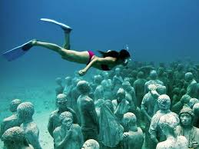

✦ Interactive Fiction– a computer programed story controlled by text commands.

✦ Plot– events that make up a story.

✦ Setting– the environment in which your story takes place. The setting can include specific information about time and place or can simply be descriptive (eg. [Molinere Underwater Sculpture Park](https://www.google.com/search?q=Molinere+Underwater+Sculpture+Park&tbm=isch&tbo=u&source=univ&sa=X&ved=0ahUKEwi0t_SonOvKAhUR62MKHcSdBroQsAQIMg&safe=active&ssui=on)).

✦ Character– a person in a novel, play, movie or Interactive Fiction.

**Procedure**

1. Form pairs as instructed by your teacher. You will be completing this Unit with your partner. In **Pair Programing** you will work together on one computer alternating who is “driving” with the keyboard and mouse. Professional coders work together to reduce errors and increase creativity. 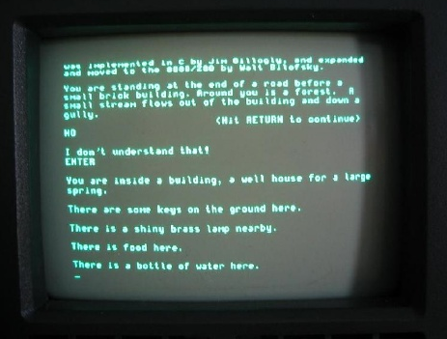

2.All stories start with a plot, read through [The Seven Basic Plots](https://en.wikipedia.org/wiki/The_Seven_Basic_Plots). Choose a plot for your story and write it it down.

3.Choose a [setting](https://en.wikipedia.org/wiki/Setting_(narrative)) and write it down.

4.Choose the [character](https://en.wikipedia.org/wiki/Character_(arts)) your user will play as, you may also have other characters your user interacts with. Write down your characters.

5. Now the fun part! Using your plot, setting and characters write a short story. Here is a suggestion from author Rebecca Makkai.

Most stories we tell in real life are under 500 words. You're at a party and suddenly you have the floor. You throw out your little story like a grenade. “Once I knew a guy who...” And if you have any social graces at all, you probably keep it under 500 words. So my advice would be this: Just tell a story, quick while they're still listening.

6. In lesson 3.1.1b you will build a story map!